USER MANUAL TO CSCI3170 PROJECT By Group 3

1155026039,1155026053,1155043822

**JAVA PROGRAM PART**

To launch the java app, user should type

java –classpath ./ojdbc6.jar:./ Project

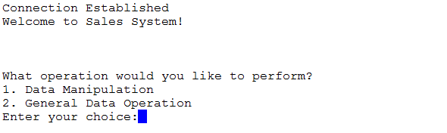

And the result for successful connection is shown above.

* **Data Manipulation**

1. Create Tables
   1. Successful Example

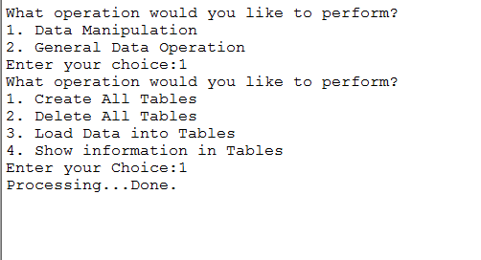

* 1. Error Example

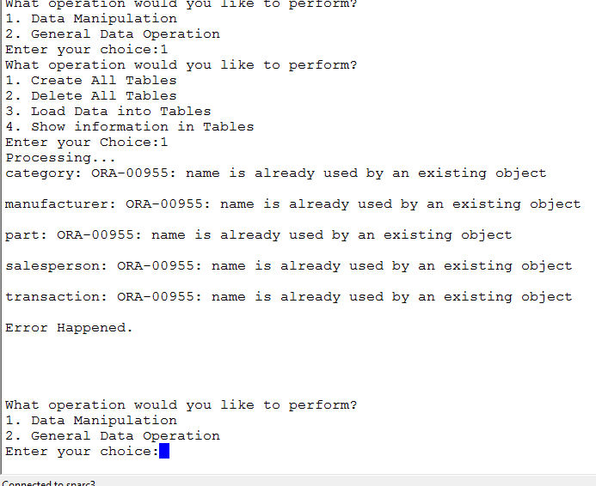

**On error, the app will report the error and then return to the upper menu.**

1. **Delete Tables**
   1. **Successful Example**

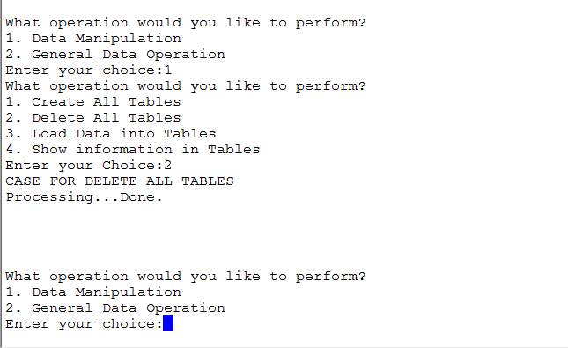

* 1. Error Example

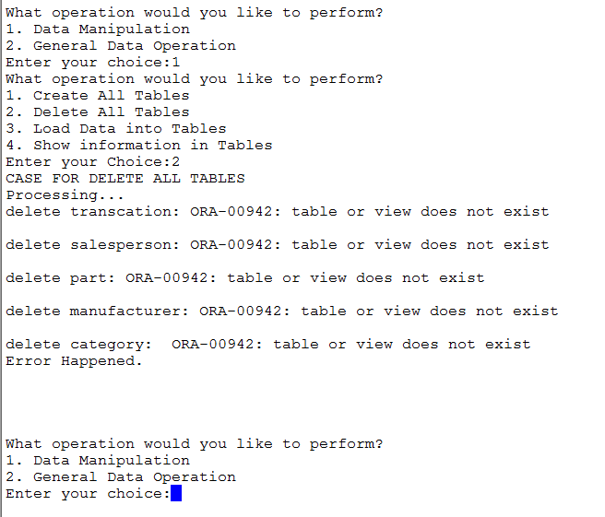

**On error, the app will report the error and then return to the upper menu.**

1. **Load Data into table**
   1. **Successful Case**

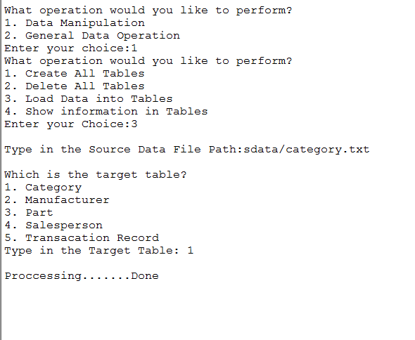

* 1. **Error Case**

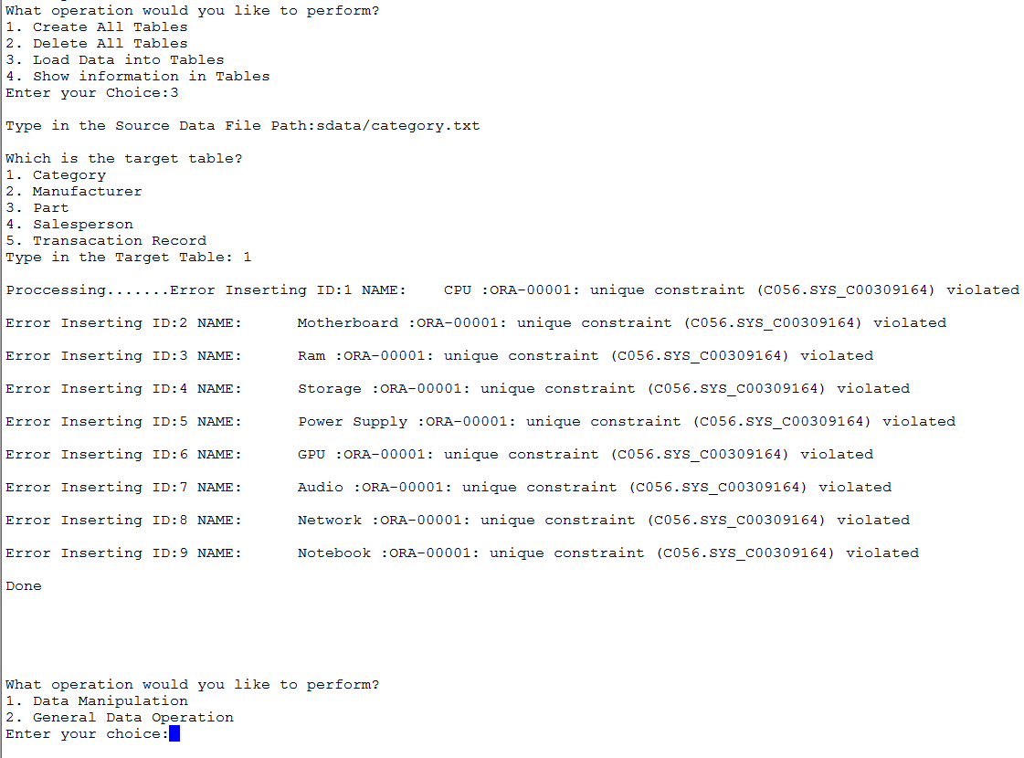

**In case of error, the error message will be shown and the app will return to the main menu.**

1. **Show Table information**

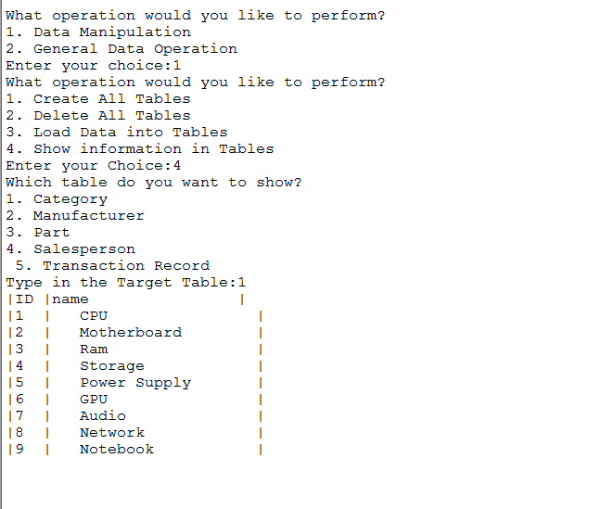

* **General Operation**

1. **Show and list parts**

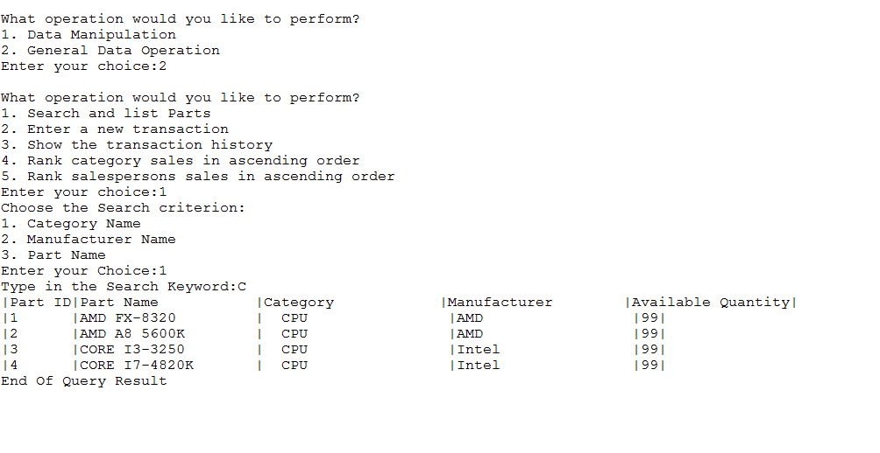

1. **Enter new transaction**

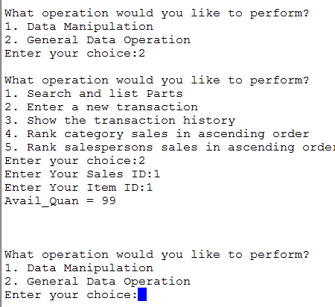

**On Success, the app will return you with the available quantity of the part before your transaction is added.**

**If the part has been sold out, the app report an error**

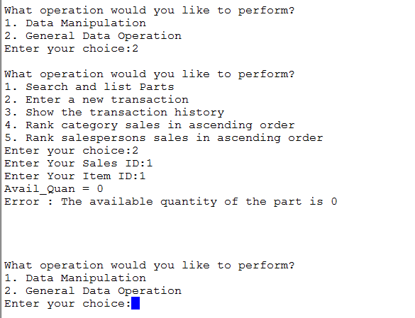

**If the part you enter doesn’t exist, the app shows an error**

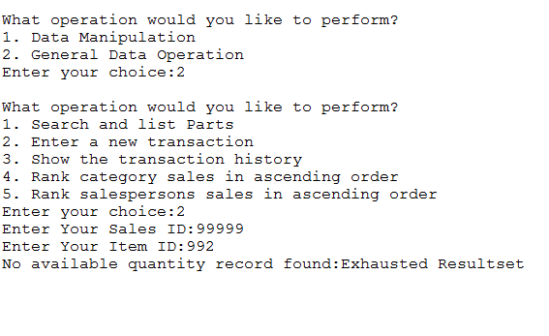

**and return to the main menu**

**If your salesperson ID is not valid, the app reports an error:**

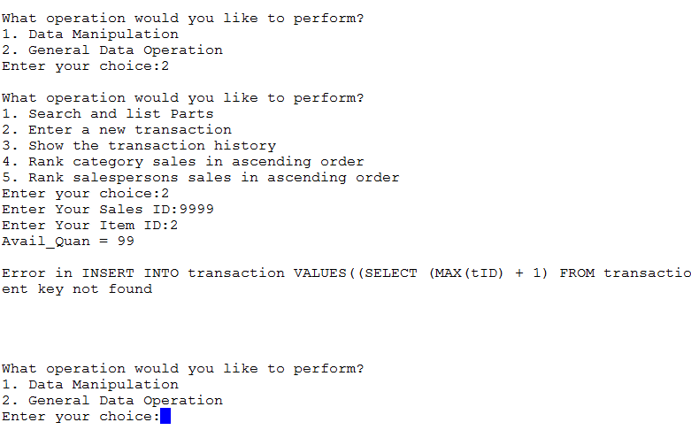

**and return to the main menu.**

1. **Show the transaction history of a salesperson or a part**

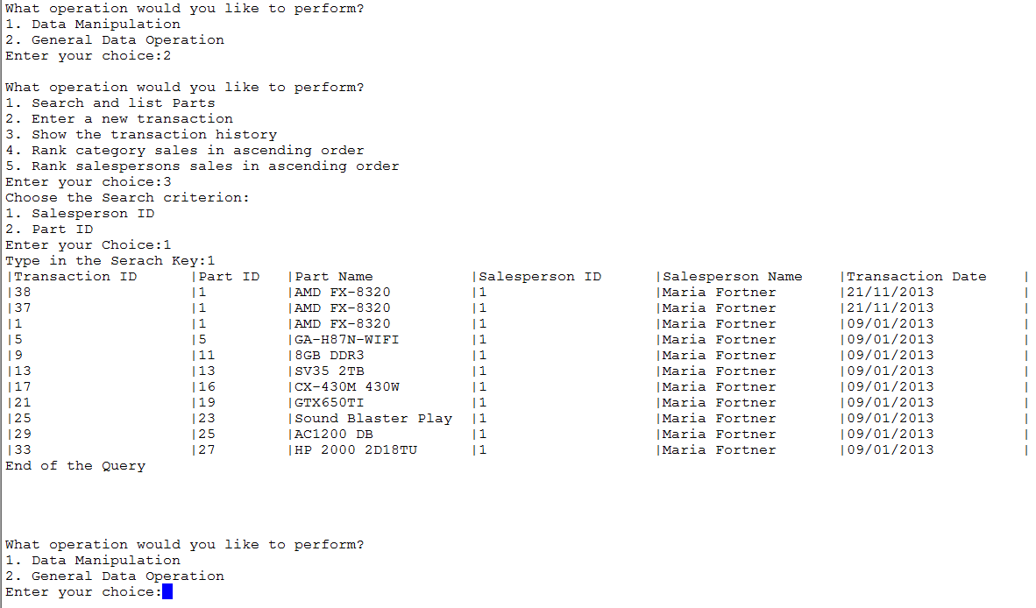

1. **Sort and list the computer category in ascending order of total sales value**

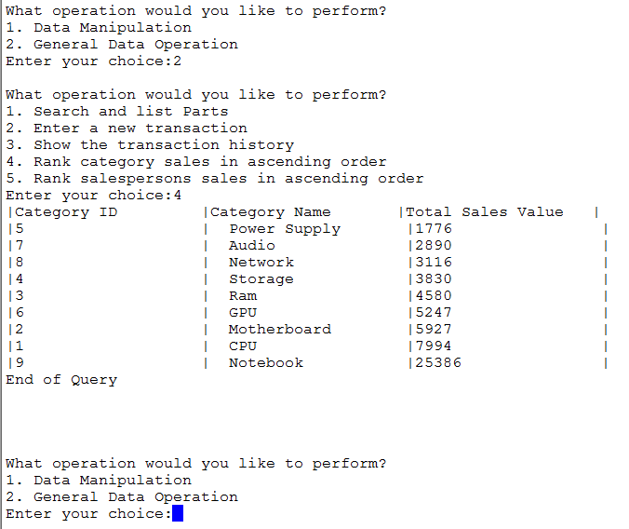

1. **Sort and list salesperson in ascending order of total sales value**

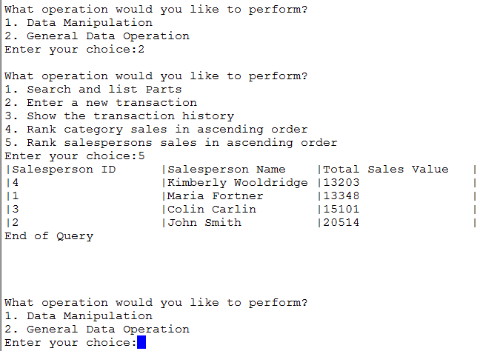

**PHP Part**

**Visit** <http://pc89123.cse.cuhk.edu.hk/~r03/index.php>

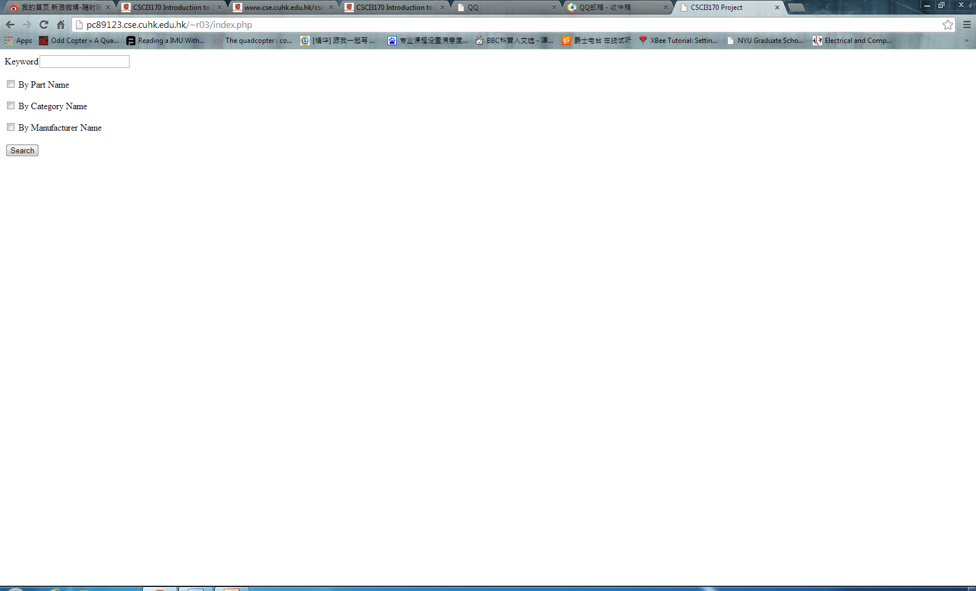

**And type any keyword you want to search, select the corresponding search option(search by Part Name, search by Category Name or Search by Manufacturer Name)**

**If no matching record is found, the browser displays a table without any record.**

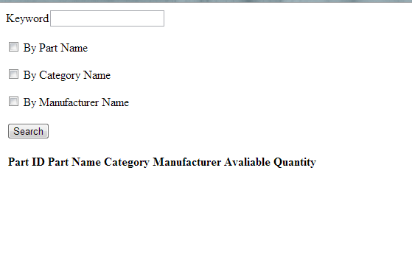

**If any matching record is found, the record will be displayed**

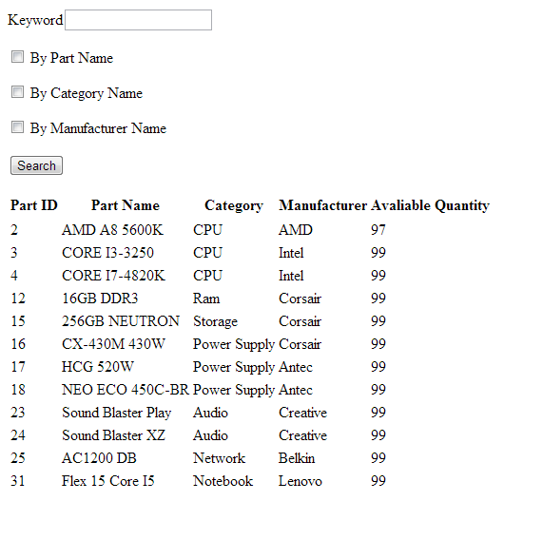

**You can specify at least one search option, if more than one search option is selected, the search will be performed in term of each search option one by one, and then display all the matching records.**